In this file, I have included some screenshots of my work during the first workshop I attended. I have pointed out which exercises are mine and constitute the evidence for my descriptors.
Screenshot 1: In this screenshot I have uploaded the criteria for selecting a computer program or application to use inside the classroom. It was uploaded on the Linoit website (DESCRIPTOR 2).
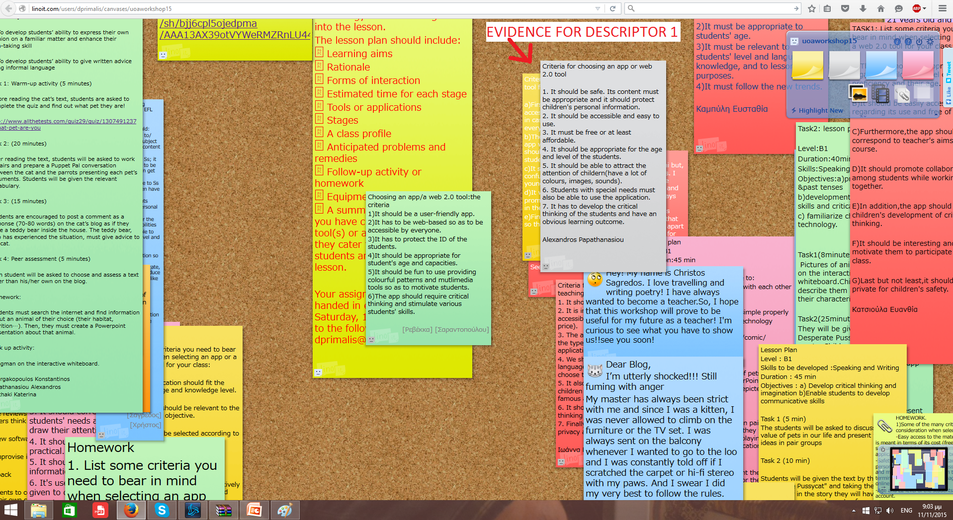
Screenshot 2: In this screenshot my colleagues (Georgakopoulos Konstantinos, Vlachaki Aikaterini) and I have created our first lesson plan with the guidance of our teacher. It was uploaded on the Linoit website (DESCRIPTOR 2).
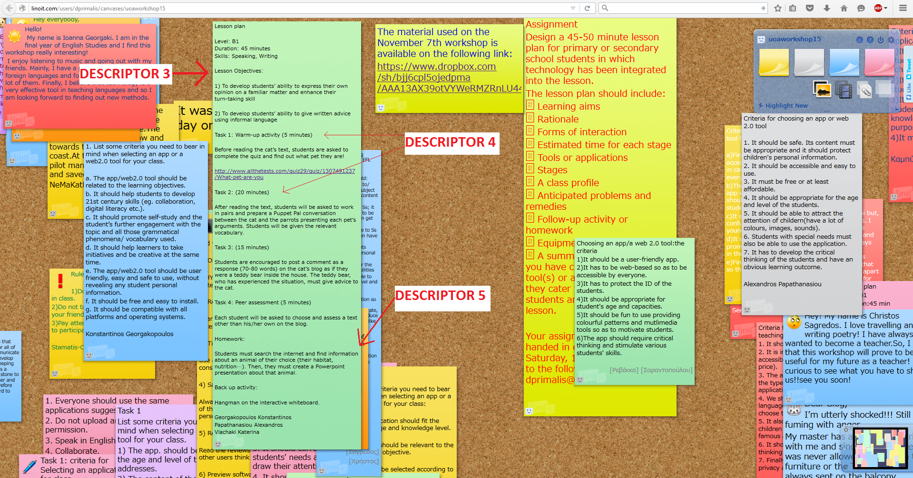
I would also like to state another evidence for DESCRIPTOR 2. Our teacher, Mr. Primalis, showed us a video of his students doing a speaking activity using the Puppet pals application. He also pointed out how to download it and made sure we understood how it works.

