This is the final project that I created in cooperation with my colleagues (Georgakopoulos Konstantinos, Vlachaki Aikaterini). It is the outcome of what we learned and designed in the four sessions of the workshop we attended. It is a proposal on how we would teach employees of a company that wants to export products. It is consisted of a class profile, needs analysis, goals and objectives, syllabus with rationale, assessment criteria and a lesson plan from one unit of the syllabus with activities and rationale. I have stated with capital letters and red color (eg. DESCRIPTOR 6) the evidence for the descriptors I have used to do self-assessment.

National and Kapodistrian University of Athens
Faculty of English Language and Literature

FAO: Michael Robbs.

Georgakopoulos Konstantinos
15632012 00030
Papathanasiou Alexandros
15632012 00205
Vlachaki Aikaterini
15632012 00021

TEFL Practicum
Date of Submission: 22/12/2015
CLASS PROFILE
Student Profile: (DESCRIPTOR 1)
A company that produces honey in Attica called “MeliAttiki” has hired us to train the members of the Public Relations Department. The company would like to export honey in various European countries and it considers it necessary that 12 of its members communicate with potential customers in English. The lessons will last for 5 weeks, with two, two-hour sessions per week. We have created a questionnaire for our clients (see pg. 4) in order to determine their level of proficiency. We also asked their employer to provide us with each member’s C.V. The clients seem to have the B1 Certificate of English which is important for their effective participation in the lessons.
Regarding the means analysis, the lessons will take place from 9.00-11.00am on-site, every Monday and Thursday in the conference room of the company. We have been informed that there is a forum available (W.C., lunch area). The material used will mainly include excerpts from course books, recordings of dialogues and exercises designed by us. These will be based on real life material, used and created by the members such as their e-mails, phone calls and contracts that the company has provided us with. Copies of the units and exercises prepared by the teacher will be distributed in each session and whenever necessary a recording/video will be played on the teacher’s tablet.
Needs Analysis: (DESCRIPTOR 1)
Language needs: Listening, Business Vocabulary (trade, import/export, marketing), Speaking, basic Pronunciation rules (sound discrepancy), socializing (small talk)
Business skills: Negotiations, Telephoning, Giving Presentations, Meetings
Learning Aims:
- The aim is for the members of the Public Relations Department to be able to communicate effectively in oral and written English.
- They will learn how to successfully promote their company and products to potential, foreign customers in English.

Learning Objectives: (DESCRIPTOR 2)
- The participants will enhance their communication skills such as turn taking, learning to express different opinions and the use of diplomatic language.
- They will have confidence in speaking which inspires security and proper marketing skills to promote their products.
- They will be able to deal with customer complaints over the telephone or e-mail.
- They will be able to present their products in an appropriate way to attract customers.
- They will be able to effectively participate in meetings with people of different cultural backgrounds and they will learn to be tactful in addressing them.

QUESTIONNAIRE
(DESCRIPTOR 1+2)
- Personal
Surname: .................................................................................................................................. Name: ..................................................................................................................................
Age: ..................................................................................................................................
Telephone: ..................................................................................................................................
Email: ..................................................................................................................................
Job description: .................................................................................................................................

- Language Skills

- How do you use English now?

- What would you like to be able to do in English?

- What expectation do you have of this language course?

- Please tell us about your language level at the moment (Now) and your priorities for improvement by the end of your course (Future), where 1-5 correspond to:

None (1)/ Not great (2) / OK (3)/ Good (4) / Excellent (5)
Now Future
- your fluency and confidence in speaking ........ ........
- your accuracy when you speak ........ ........
- your understanding of other speakers ........ ........
- your accuracy when writing ........ ........
- your range of vocabulary ........ ........
- your reading comprehension ........ ........
- your use of grammatical forms ........ ........

- Business Skills

- Please tell us how much you expect to use English in the following contexts where1-5 correspond to:
Never (1)/ Rarely (2)/ Sometimes (3)/ Frequently (4)/ A lot (5)
- telephone calls
- conversation and informal meetings in small groups
- participating in formal meetings
- negotiating
- addressing an audience - giving presentations
- taking notes during meetings, conferences etc.
- making recommendations
- writing business letters, emails etc.
- working with others who speak English
- dealing with dissatisfied customers
- promoting and selling products
- advertising your company

SYLLABUS (DESCRIPTOR 2)

Week 1
Session 1 - Socializing
Vocabulary: Fixed expressions and greetings (e.g.“Nice to meet you.”, “Thank you for your time.”), breaking the ice
Grammar: Tag questions (e.g.“My office wasn’t that far, was it?”), yes/no questions, wh- questions (e.g.“Who is the head of the department?”, “What time shall we meet?”)
Speaking: Communication skills, learn to present yourself, asking appropriate questions

Session 2– Coping with formal scenarios
Speaking: Formal and informal language, how to address colleagues and people superior in the job hierarchy, basic pronunciation rules
Listening: Minimal pairs, sound discrepancy
Week 2
Session 3 – Promoting the company
Reading and Vocabulary: Business and management terminology frequently used in business t Texts (e.g. “elasticity of demand”, “flexecutive”)
Marketing skills: Attracting potential customers, skills and tips regarding advertising and making products attractive, making offers and recommendations in speaking activities

Session 4– Dealing with customers 1
Listening: Telephoning
Speaking: Handling questions and complaints, use of diplomatic language
Vocabulary: Appropriate expressions used in similar situations (e.g.“Can I speak to…?”, “Could you tell me what the problem was?”), modality (integration of grammar)
Week 3

Session 5 – Dealing with customers 2
Reading: Sample emails, letter of complaints
Writing: Writing outlines, emails, learning to use formal expressions used in writing

Session 6 – Meetings 1
Listening and Speaking: Preparation for negotiations, bargaining, making offers and deals (e.g. “I'd like to speak to the company manager”, “You can get 2 packages in the price of 1 only if….”)
Communication skills: Diplomatic language (e.g. “I think that it might be possible to offer you a discount if you…”)

Week 4
Session 7 – Meetings 2
Listening and Speaking: Accepting and rejecting offers negotiating, confirming and ending negotiations (e.g. “Thank you for your time and assistance”)
Communication skills: Watching videos of colleagues from different parts of the world in meetings, teaching ethical behaviour, social performance, and body language

Session 8 - Giving presentations 1
Presentation skills: How to organize ideas in an outline, summary of main points, organization tips, stress management for presentations

Week 5

Session 9 - Giving presentations 2
Communication skills: What makes a lecture interesting, raise cross cultural awareness, body language, and tact in addressing different audiences
Speaking skills: Rehearsal of what they have learned in Sessions 8 & 9

Session 10– Assessment (DESCRIPTOR 6)
Speaking: Simulation activities as an assessment of what the students have learned in the course. The activities will be based on real life situations that students will probably face (phone calls, meetings) (DESCRIPTOR 5)
Writing: Email as a response to a customer

RATIONALE
The skills taught in each session are in accordance with real life situations; the sessions follow the order in which these professionals will be asked to use their skills for the purposes of their job. More specifically, the members of the Public Relations department are expected to first contact potential customers and promote the company. Then, they will probably have to deal with customers and engage in meetings, or even give presentations.
As a result, the syllabus has been designed according to the students’ specific needs which constitute the aims of this course. Students will be able to interact with customers using both oral and written English, in order to serve the needs of the company. Thus, the first sessions (Sessions 1 & 2) focus on developing the students’ listening and speaking skills in the appropriate context (communication skills).The sessions following the introductory ones (Sessions 3, 4 & 5)focus on speaking and writing in professional, business-like context, along with some basic marketing skills, such as advertising, promoting products and dealing with dissatisfied customers. The next sessions prepare the participants for face to face interaction with their customers (Sessions 6 & 7)and to give presentations (Sessions 8 & 9). Finally, Session 10 has been designed in order for the teachers to assess the students’ overall performance.
Most of the sessions focus on the skills of listening and speaking, as it is assumed that this will be the students’ primary need. Nevertheless, basic reading and writing skills will also be developed during this course. Vocabulary and grammar are integrated within the lessons and are not separately taught. The main aim is to develop language skills as a means of promoting the company and serving its goals. However, apart from the linguistic goals that need to be attained, business and marketing skills are also integrated in the teaching process.

ASSESSMENT (DESCRIPTOR 6)
Assessment for this course is both formative and summative. As far as formative assessment is concerned, some minutes are dedicated at the end of each session to assess the students’ performance. The teacher keeps notes of their performance throughout the session, and provides feedback in the form of comments. Emphasis is placed primarily on fluency, while basic accuracy mistakes will also be corrected. Throughout the sessions, the teacher listens unobtrusively without interrupting the students, so as not to cause inhibition, unless there is a breakdown in communication.
Concerning the summative assessment of the students, Session 10 has been entirely devoted to it. Students will be assessed by participating in simulation activities which will reflect what they will face in real life as their job duties (e.g. the teacher has the role of the customer and each student tries to make a deal, present the products of the company or handle a complaint depending on the situation). These simulation activities help the teacher to determine whether the students are able to communicate effectively in English. Moreover, students will be asked to engage in a brief writing task (email) in order for the teacher to assess whether they are able to organize their ideas and form a coherent text in English.
Based on the students’ performance in this session it will be possible for the teacher to determine whether the course objectives have been covered and whether the teaching process has been successful. Finally, the teacher will inform the employer of the members of the PR Department concerning their performance and progress during the whole of the course.

LESSON PLAN (DESCRIPTOR 3)
Session 4 -Dealing with customers 1
STAGES | MATERIAL | TIMING | INTERACTION | ACTIVITY | RATIONALE
Icebreaker |  | 3’ | Student- Teacher | “Did you use your English this week?” | Break the ice between the teacher and the students and encourage communication in English.
Warm up |  | 10’ | Student- Teacher | “Has anyone ever called you to complain about your products/ services?”  “How did you handle those complaints?” | Introduce the topic, give them an idea of what follows, and understand what the Ss already know.
Presentation | Recording from  “English for Marketing & Advertising by Oxford Business English” | 17’ | Group Listening | Activity 1  (see pg. 13)  Jigsaw activity | Introduce relevant vocabulary, enhance the Ss listening skills, and make them familiar with a real life situation that they will experience in the near future. The jigsaw activity is used to encourage cooperation between Ss.  The teacher takes notes on the blackboard.
Practice | Recording and Transcript from “English for Marketing & Advertising by Oxford Business English” | 15’ | Individual Work | Activity 2  (see pg. 13)  Information Gap | The Ss have the conversation script in front of them with words missing. They practice vocabulary to further understand how it is used  in relation to the proper context.
Break |  | 15’
Practice  (continued) | Exercise prepared by the teacher | 10’ | Individual Work | Activity 3  (see pg. 14)  Information Gap | The Ss are given an exercise with words missing. They practice vocabulary in a situation regarding a honey company to further understand how it is used in relation to the proper context.
Production | Vocabulary and Expressions based on their notes | - 20’  - 20’ | Pair Work | - Activity 4  (see pg. 14)  - Activity 5  (see pg. 14)  Simulation | Brainstorming of ideas, interaction between students, cooperation. It is a real life situation which apart from linguistic elements, also focuses on Ss’ development of marketing skills and diplomatic language Teacher monitoring the whole process and notes down possible errors but does not intervene in the discussion.
Remedial Work/ Assessment  (DESCRIPTOR 6) | Teacher’s comments and notes | 10’ | Feedback/ Assessment | Feedback in the form of corrections (accuracy). Assessment will also be based on Ss’ participation in the communicative activities (fluency). | The teacher provides feedback so that the Ss do not make the same mistakes.

Activity 1 (DESCRIPTOR 4)

Listen to the following recording, form 3 groups and take notes.
Group A: Write expressions regarding telephoning
Group B: Write expressions regarding how to form complaints
Group C: Write expressions regarding how to handle questions and deal with complaints

Activity 2 (DESCRIPTOR 4)

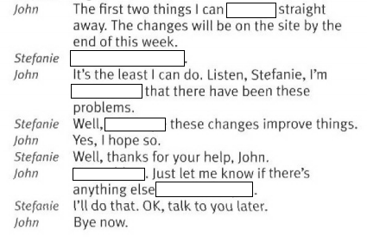
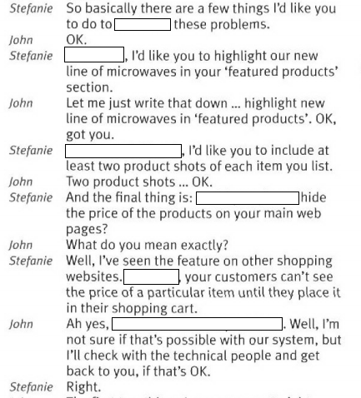
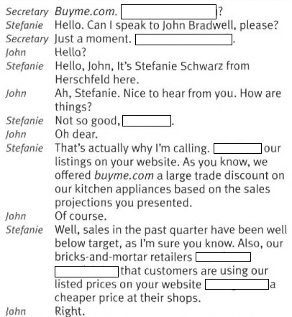
Listen to the recording and fill in the gaps:

Activity 3 (DESCRIPTOR 4)

Fill in the gaps using the following phrases:
assure, bringing this incident, can you tell me, could you, deeply regret, how can I, I must apologize, if you would accept, I'm sorry to, I'm terribly sorry, may I ask, of course, one moment, right
Customer: "I'd like to speak to the company manager. What's his name?"
Employee: "Of, course madam. Our manager is Mr.Ioannou.  your name?
Customer: It's Mrs Greenwood from Green enterprises.
Employee: , Mrs Greenwood and I'll ask Mr. George Ioannou to speak to you.
Manager: Good afternoon, Mrs Greenwood. help you?
Customer: I have a complaint to make about the honey package I received yesterday.
Manager:  what the problem was?
Customer: The packaging was torn and some of the vases were slightly damaged.
Manager:  hear that madam.
Customer: I haven't finished. The package was delivered with a 2 day delay!
Manager:  about this, Mrs Greenwood. tell me the number of the order.
Customer: It is 5874 569.
Manager:  for what happened and I  you I will deal with it as soon as possible.
Customer: But what are going to do with my order?
Manager: We will offer you a refund. I  the trouble caused and ask  a discount for your next order.
Customer: That sounds reasonable.
Manager: Thank you for  to our attention. This is the only way we can put your problems right.

Activity 4 (DESCRIPTOR 4) (DESCRIPTOR 5)

Work in pairs of 2 and imagine that one of you is a customer who is calling to complain about an order and the other is the member of the PR department. Write down what the problems are and then try to find possible solutions. Rehearse the dialogue.

Activity 5 (DESCRIPTOR 4) (DESCRIPTOR 5)

Act out the dialogue in front of the class using the relevant vocabulary.

