Listening
1) Match the vocabulary with the correct definition and write a – e next to the numbers 1 – 5.

- To spit a. To make a continuous sound with the lips closed
2. To shear b. Soft thick hair that grows on the bodies of animals like sheep
- Wool c. To cut the wool off a sheep or similar animal
4. To lick d. To force out liquid from the mouth
5. To hum e. To pass the tongue over a surface
2) Check your understanding: true or false

1. Llamas, alpacas, vicuñas and guanacos are all related to camels. True False
2. Llamas are the smallest of the four. True False
3. Llamas only spit at humans if you treat them badly. True False
4. Alpacas look as if they are sad. True False
5. Alpaca wool is good for clothes. True False
6. Vicuña wool is very expensive. True False
7. Vicuñas eat cacti. True False
8. Llamas and alpacas can’t live in the UK. True False
3) Complete the gaps with a word from the box.
dogs - wild – stressed - relaxed
warmer - gentle - three - softer
herds – curious - foxes - 4,000 metres

1. Llamas and alpacas are both domesticated animals and vicuñas and guanacos are_______________.
2. Llamas are very sociable animals and live together in groups, in _______________.
3. They respond well to being trained and they are usually _______________ and _______________.
4. The alpaca is famous for its wool, which is _______________ and _______________than sheep’s wool.
5. Vicuñas can only be shorn of their wool every _______________ years.
6. Guanacos are capable of surviving at over _______________ in the Andes.
7. Llamas hum when they are _______________, or the opposite, feeling _______________.
8. Sometimes farmers use llama to protect sheep and hens from animals that might attack them, like _______________ or _______________.

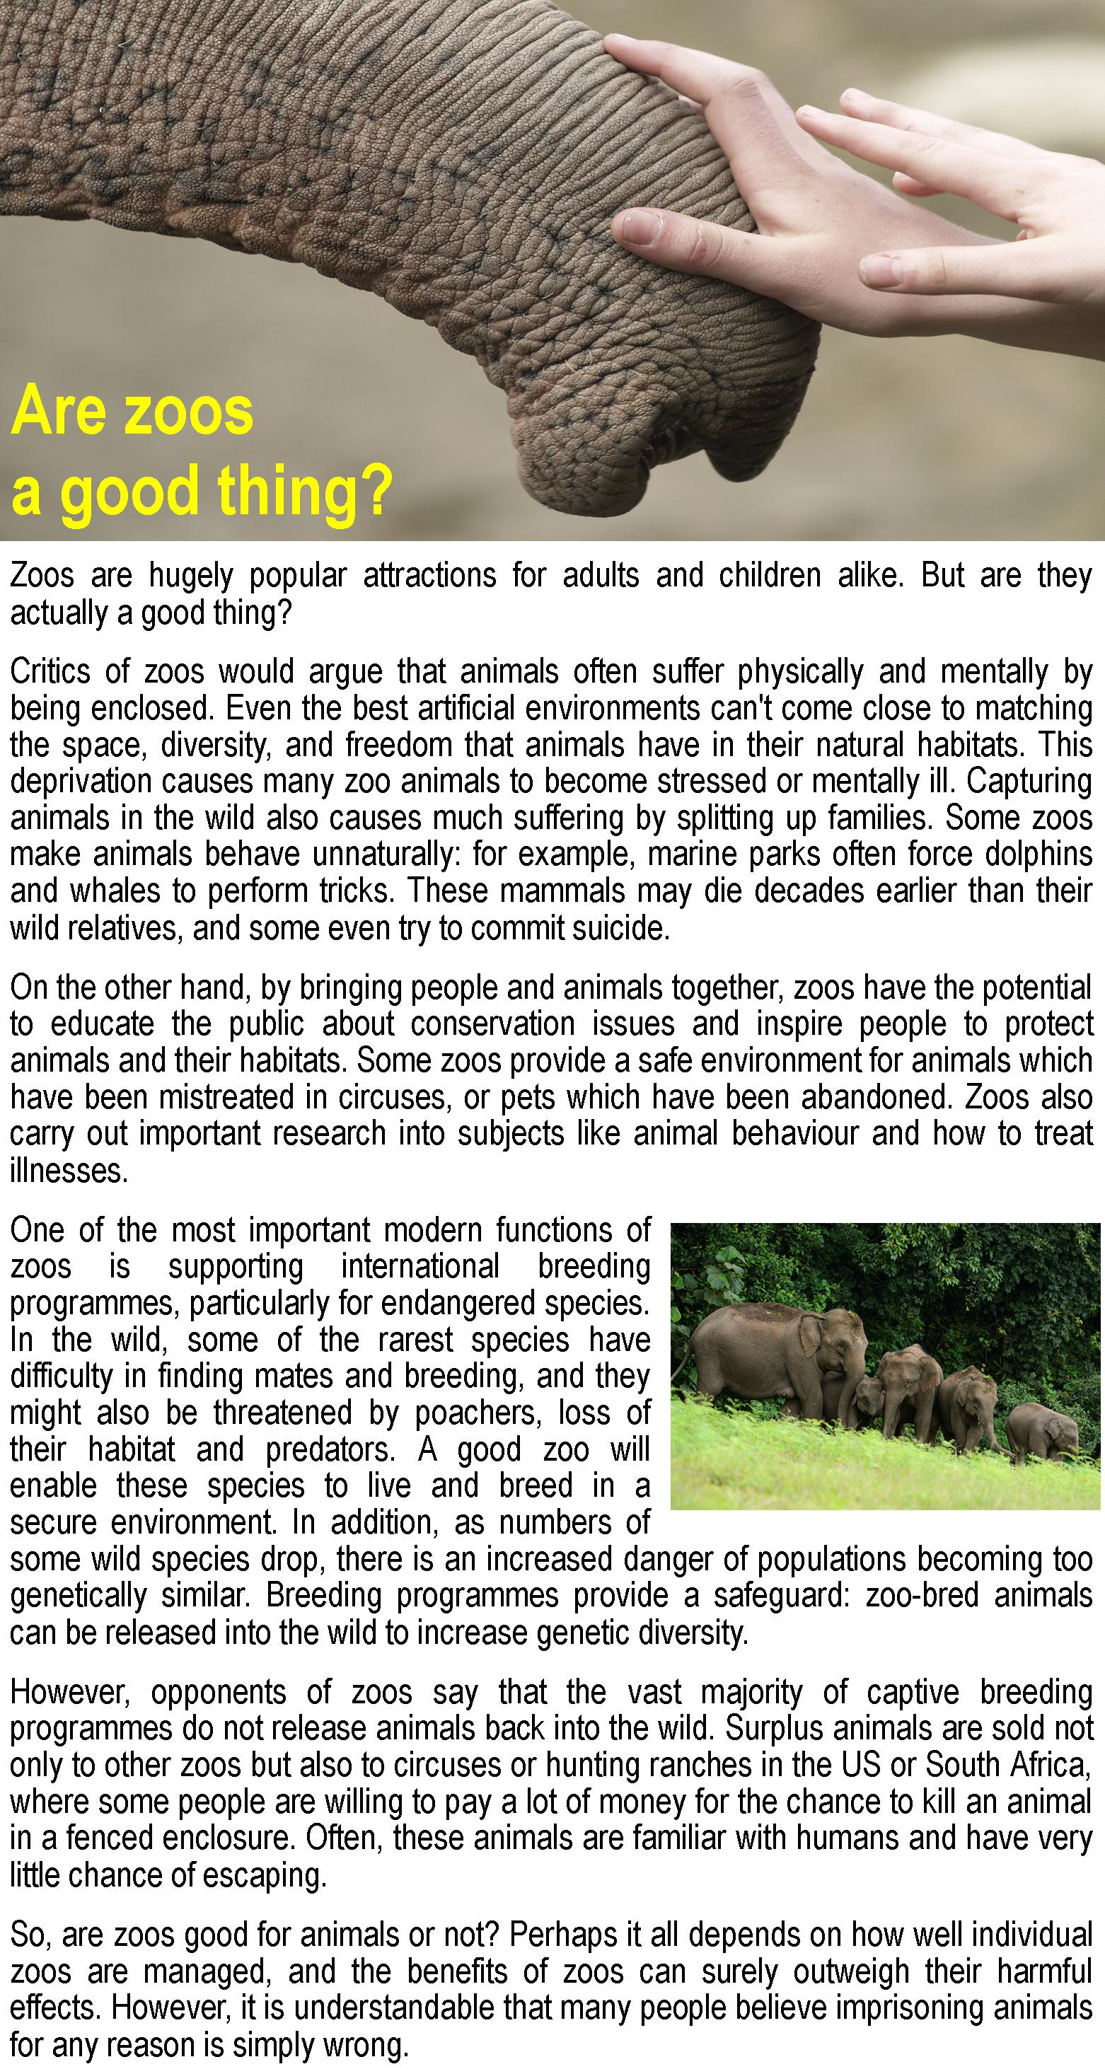
Reading exercises

1) Are the sentences true or false? Write T or F.
A) Modern zoos can offer animals a living environment that is as good as their natural habitats.
B) One of the reasons zoo animals become distressed is because they are separated from their families.
C) Dolphins and whales usually live longer in zoos than in the wild.
D) People who have visited zoos are more likely to support animal conservation and protection.
E) Zoos protect animals from being used for scientific research.
F) Endangered animals kept in zoos are less likely to meet a mate and breed.
G) In their natural habitats, animals suffer problems related to human activity.
H) Endangered species often lack genetic diversity in their population.
I) Zoos promote genetic diversity by breeding animals and then releasing them back into the wild.
G) If zoos have more animals than they can look after, they always give them to another zoo or release them back into the wild.
K) Animals that have been bred in captivity quickly adapt to life in hunting ranches.
L) The author thinks that, on balance, zoos are generally a good thing.

2) Find a word in the text that means:
Lack=
100 years=
Preservation=
Motivate=
Give birth=
Additional=
Single person=
Prisoner=

Vocabulary

1) In the text you read that the benefits of zoos outweigh their harmful effects. Complete the sentences below with other verbs with the prefix out, paying attention to the tense.

Outweigh - outsmart - outnumber - outperform

A wolf is strong, but a fox manages to _____________ him.

All things considered, the advantages clearly _____________ the possible disadvantages.

In our class, the girls _____________the boys.

Last year Toyota ______________ other Japanese cars.

What do the meanings of all the above verbs have in common?

2) Fill in the gaps with the correct word. There is one extra word.
Benefit - marine – public - diversity - predator - population

- You know, it is to your _________to study history.

- He decided to join the _________corps.

- I hate when people use bad language in _________public places.

- Tyrannosaurus rex, is considered the largest _________ever to have walked the earth.

- Our oceans are home to a rich _________ of species.

LINKS FOR MATERIAL:
https://learnenglishteens.britishcouncil.org/skills/listening-skills-practice/llamas
https://learnenglishteens.britishcouncil.org/skills/reading-skills-practice/are-zoos-good-thing

