- The following article explores the relationship between dogs and humans. After reading the text, identify and underline 8 idioms regarding friendship.
California Science Show Explores the Dog-Human Friendship
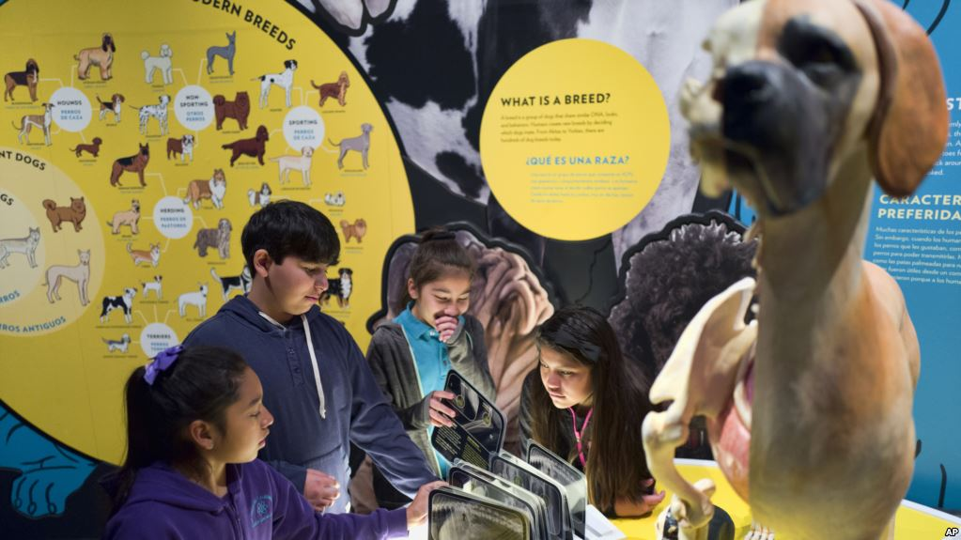
In this Tuesday, March 12, 2019 photo students from the Theodore Alexander Science Center School check an interactive display of the internal organs of different dogs at the California Science Center in Los Angeles. (AP Photo/Richard Vogel)
Did people decide to fall in love with dogs or did dogs choose people? And why do these two species seem to be like two peas in a pod?
The California Science Center has spent the past five years finding the answer to those and many other questions about dogs. These answers came with the recent opening of a show called "Dogs! A Science Tail."
And, yes, real dogs will be there.
"It's really not...just dogs and science. It's really about how dogs and humans are both social animals…because we are both social animals, we've learned to work together," said Jeffrey Rudolph. He is the center's president and a dog lover who worked for years to put this show together.
As he spoke just before the show opened, he stopped at a representation of a fire hydrant. Next to it is a button. When pushed, it lets visitors smell what a dog smells.
Rudolph said that while humans would just smell an awful odor, “a dog can tell what dog was there, what time they were there and actually which direction they were going", through their sense of smell they are able to know each other inside-out.
It is one of the ways dogs can decide how safe the area is. It is also how they tell time.
"They have an amazing ability to learn information," continues Rudolph. He says that dogs have 300 million sensory receptors in their noses while humans have just 6 million.
Nine similar places in the show permit people to see like a dog does --- not a very colorful display. And, visitors can learn how dogs hear sounds that humans cannot, allowing visitors to see eye-to-eye with their beloved pets.
In the museum, people could watch Garmin, a 2-year-old golden Labrador retriever who is about to complete guide-dog school and become the guiding light of disabled people. He demonstrates his skill with visitors with covers over their eyes. Garmin guides them around barriers in the path.
But do dogs really love us?
"If you look a dog in the eye, a dog will look back at you and you will produce oxytocin," said Diane Perlov, the center's senior vice president for exhibitions. Oxytocin is the chemical known as the love hormone because of the positive feelings it causes in people.
"And," she adds, "the dog will also produce oxytocin in his own body from looking back at you.”
A chimpanzee, on the other hand, will just look away.
So how did the love between dogs and humans begin? Why are there dogs in more than 60 million American houses?
Scientists are not sure. They know dogs came from wolves and that wolves and people crossed paths more than 10,000 years ago, said Perlov. They learned that humans and wolves hit it off in the hunt for food. Could that be the beginning of love?
"It is…our ability to understand each other that forms the basis of our relationship," Perlov says. We might be strange bedfellows, nevertheless, life would not be the same without man’s best friend.
Article found on https://learningenglish.voanews.com/a/california-science-show-explores-the-dog-human-friendship/4837543.html. Written by Susan Shand, adapted by Georgios Kokkolis- Papadopoulos.

- Fill in the blanks below with the idioms that you identified in the article. Match the idioms with their definition. There are two definitions that you do not need.

